HR Commander

Game Design Document

# Game Identity

Sci-fi top-down shooter about defending a planet on behalf of an evil corporation.

Game for Trijam #300, theme: Evil Corporation.

# Design Pillars

Minimalistic. Action-packed. Satire.

# Genre

Top-down shooter with bullet hell elements.

# Story

Year 2724. Humanity spread out to the nearby stars. Rapid advances in faster-than-light travel brought upon a scientific revolution, and with that, the dawn of megacorporations – corporations so powerful they use military ships to battle for control with other megacorporations and the United Earth Government.

You are a new hire of HonestGood interstellar megacorporation. You’ve been hired as Human Resources Commander for mining outpost HD 20794 c – a rocky world that’s orbiting around a main-sequence star 82 G. Eridani, 19.7 light-years away from Earth.

Your job is to expand and maintain operations on the planet. You must find new people who’d be willing to sign up the contract to work in the mines, and you must also defend the planet from incoming unfriendly ships.

# Mechanics

### Main

Move to avoid projectiles and pick up escape pods

Shoot down enemy ships before they shoot down you or reach the planet

Shoot down civilian ships before they escape, and pick up escape pods (this is how you “hire” workers)

Escape pods increase HP (you get additional funding)

Getting hit by a bullet reduces HP (you get fined for scratching the ship)

Letting Space OSHA land on the planet results in Game Over

### Extra

Use Blink ability to dash away from hard spots

# Features

### Main

Rotating planet underneath

Bullet hell

### Extra

Multiple types of enemies

Maybe a mini-boss

# Interface

### Main

Use WASD to move ship on the map

Use Mouse to aim, LMB to fire

### Extra

Use Space to blink

# Art Style

Minimalistic, limited colors, little details, no animations.

Something science-y?

Font: FFF-Forward <https://www.1001fonts.com/fff-forward-font.html>

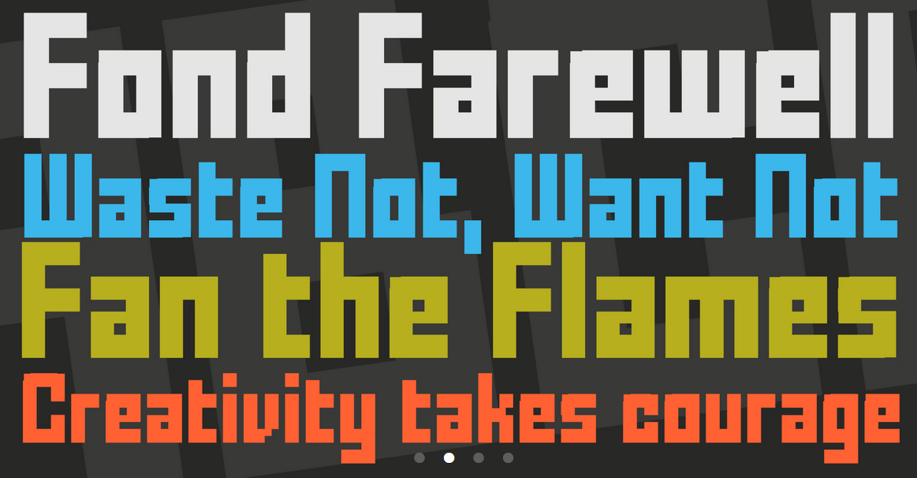

Planet idea: the real thing <https://science.nasa.gov/exoplanet-catalog/hd-20794-c>

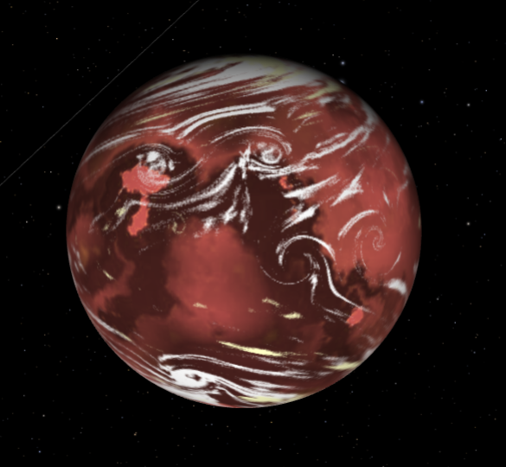

Ship ideas: <https://opengameart.org/content/1616-ship-collection>

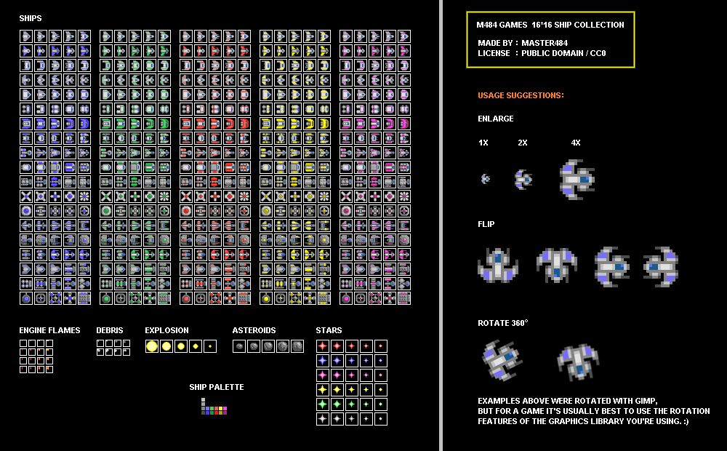

Background: The Milky Way

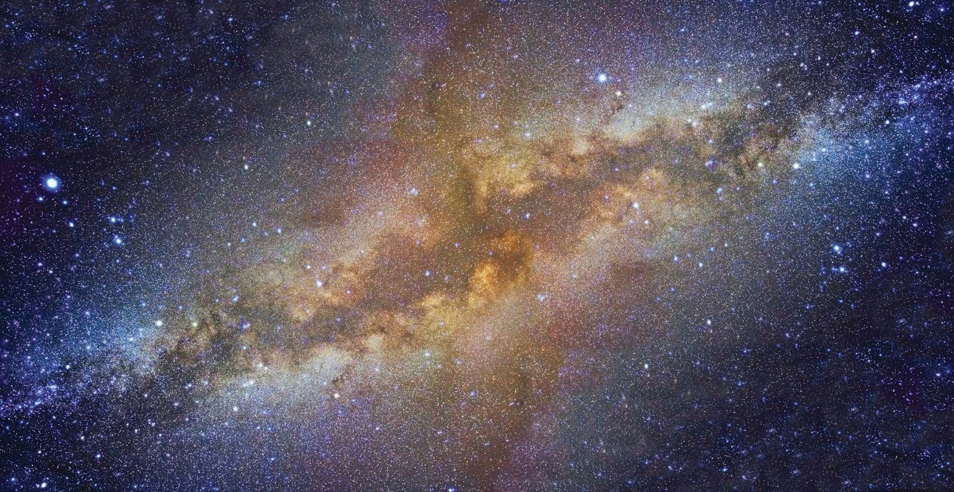

Tools: aseprite.

# Music/Sound

Will be using simple sound effects stylized to 8-bit, and a synthwave/chiptune style simple music.

Tools: bfxr for sound, UltraBox for music.

# Production planning

## Timeline

Total time: 3 hours = 180 minutes

Art: 30 minutes

Music+sfx: 30 minutes

Coding & assembling: 60 minutes

Playtesting & polish: 60 minutes

## GFX assets

### Main

1. Planet base
2. Planet clouds
3. Player ship
4. Player bullet
5. Enemy bullet
6. Escape pod
7. Enemy ship
8. Game icon

### Extra

1. Multiple enemy types
2. Boss ship
3. Galaxy background

## Music assets

### Main

1. Base gameplay theme

### Extra

1. Main menu theme
2. Game over theme

## SFX assets

### Main

1. Player shooting
2. Player takes damage
3. Enemy ship destroyed
4. Escape pod picked up
5. Game over

### Extra

1. Blink effect
2. Enemy fire

## UI layout

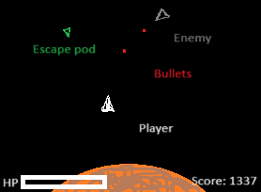

## Code

### Organization

1. Main scene: UI, planet, player, music controller, gameover UI, ship container, projectile container, spawn points for civilians and enemies, spawn script for random enemies (ramps up with difficulty).
2. UI: HP bar, score (workforce) counter, use font for theme
3. Planet: base sprite, clouds sprite, both with slight rotation animation, target position for enemies, collision area for enemies reaching planet
4. Music controller: plays gameplay theme on repeat
5. Gameover UI: displays score, little end of story text, “restart” button
6. Ship container: contains enemy ships & escape pods
7. Projectile container: contains projectiles

### Entities

1. Player: base node, collision shape, rotatable sprite, projectile spawn position, shoot timer. WASD control alters position, mouse look prompts sprite rotation, LMB triggers fire, hp counter triggers game over screen if reaches 0.
2. Enemy: base class for all non-player ships. Rotates entirely, moves, can track player and shoot at them. Needs shoot timer to prevent spamming.
3. Enemy – escape pod: cannot attack, goes in random straight line at slow speed, if collided with by player – despawns, increases player score and player hp
4. Enemy – civilian ship: cannot attack, goes in horizontal straight line at high speed, if shot down – spawns escape pods (just a piñata).
5. Enemy – govt ship: will attack player, goes towards planet, if shot down – spawns escape pods.
6. (Extra) Enemy – rival corporate ship: will attack player, goes towards player ship, if shot down – spawns escape pods.
7. Projectile – goes in straight line, despawns after a few seconds. Can collide either with enemy ships or player ship, will hurt player or kill enemy.

### Project

1. NEAREST texture filter, for pixel art
2. Physics layers: player, enemy, escape pod, planet
3. Input map: WASD, attack
4. Autoload: none
5. Project name & icon